BUSINESS PROCESS MODELING
Cart Abandonment Contextualization & Process Improvement Design

1. Relating the Scenario to Available Data
The project scenario assumes that the eCommerce company is facing:
- High cart abandonment rate
- Declining sales performance
However, the available dataset does not contain explicit cart-level interaction data (e.g., add-to-cart logs, session drop-offs, or checkout exits). Therefore, cart abandonment cannot be directly measured.
To address this limitation, cart abandonment has been inferred through behavioral and operational indicators such as:
- Order cancellations
- Cancelled-after-approval cases
- Delivery delays
- Low customer review scores
- Weak repeat purchasing behavior
These indicators act as proxy signals of abandonment risk, particularly at late checkout or post-purchase stages.
Thus, while the dataset does not show extreme abandonment numerically, structural risk areas within the process can still contribute to perceived abandonment and declining customer retention.

2. Current State Process (AS-IS)
2.1 Overview
The current BPMN model maps the end-to-end checkout and fulfillment process across four actors:
- Customer
- E-Commerce System
- Seller
- Carrier
The flow begins at checkout initiation and ends after delivery and review submission.

2.2 Cart Abandonment Risk Points Identified
1. Payment Gateway Decision Stage
At the exclusive gateway “Payment Approved?”, customers may exit if payment fails.
Even though cancellation rate is measured at 0.63%, this stage remains a structural abandonment risk point because:
- Payment failures cause immediate termination
- No retry loop exists
- Error messaging is not structured
This represents early-stage checkout abandonment risk.

2. Cancelled After Approval Risk
Orders approved but later cancelled indicate friction between:
Payment Confirmation → Seller Fulfillment
This represents late-stage abandonment, where operational inefficiency overrides successful checkout.
This weakens trust and can reduce repeat purchase probability.

3. Delivery Delay Bottleneck
Analysis shows:
- 1-star reviews: average delivery ~20.85 days
- 5-star reviews: average delivery ~10.22 days
This indicates that long delivery times are strongly correlated with dissatisfaction.
Although not classic “cart abandonment,” this leads to:
- Reduced repeat behavior
- Negative brand perception
- Silent churn
Over time, this contributes to declining effective sales performance.

2.3 Limitation of Current Model
The current process is reactive:
- No SLA enforcement
- No proactive monitoring
- No structured payment recovery
- No post-delivery engagement trigger
These gaps increase long-term abandonment and retention risk.

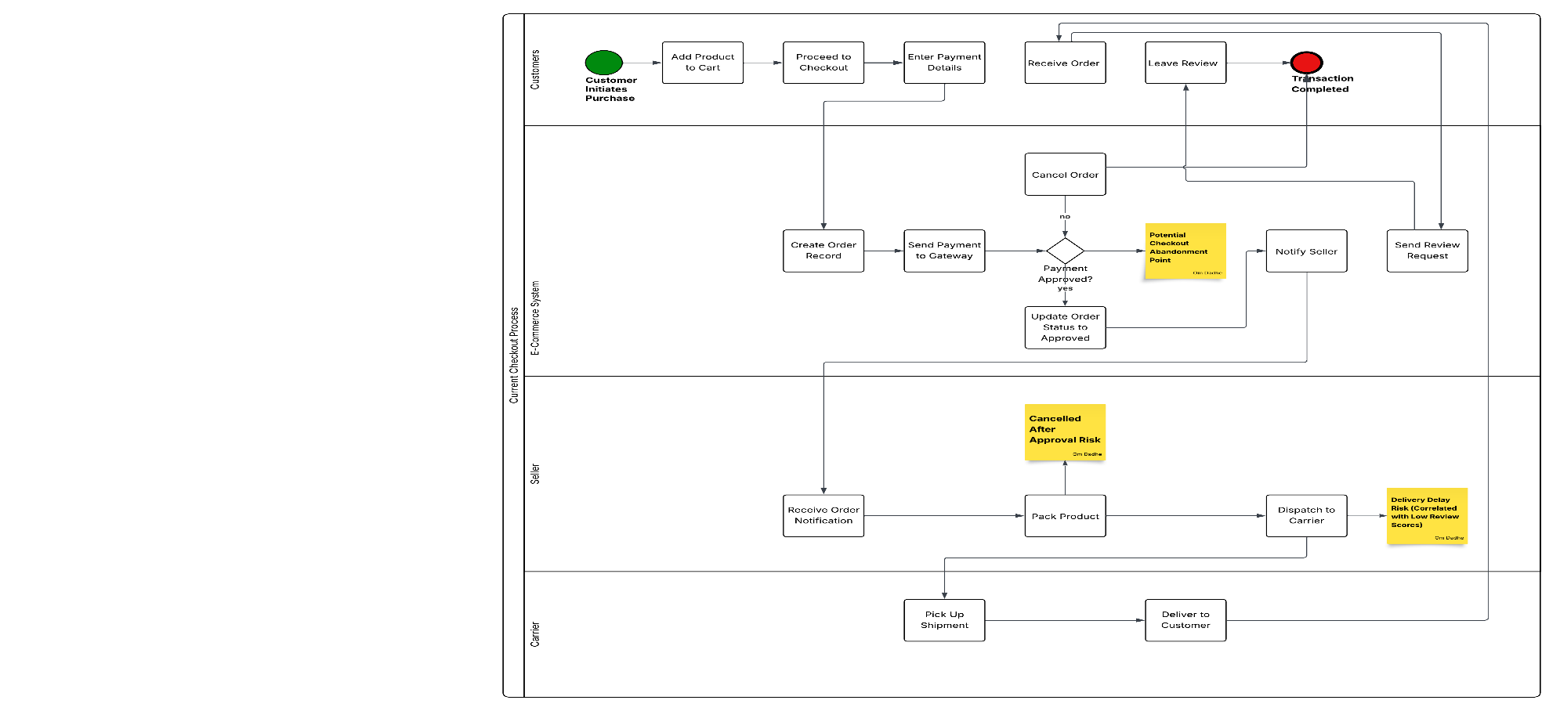
Fig 1 : Current Checkout process

3. Future State Process (TO-BE)
The redesigned BPMN model introduces preventive and monitoring mechanisms aligned with the scenario.

3.1 Addressing Checkout Abandonment Risk
Improvement 1: Transparent Pricing
Final cost including freight is displayed before payment.
Why this matters:
Unexpected charges are a primary driver of checkout abandonment in eCommerce.
Impact:
Reduces early-stage drop-offs.

Improvement 2: Payment Retry Mechanism
If payment fails, the system allows retry with clear messaging.
Why this matters:
Many payment failures are technical, not intentional abandonment.
Impact:
Improves checkout completion rate without increasing acquisition cost.

3.2 Addressing Operational Drop-Off Risk
Improvement 3: Seller SLA Monitoring (Parallel Gateway)
After payment approval:
- Seller is notified
- SLA timer starts in parallel
If delay exceeds threshold:
- SLA breach event triggers
- Operations team alerted
Why this matters:
Delivery delay is directly linked to dissatisfaction in the dataset.
Impact:
Reduces operational-driven churn.

3.3 Addressing Long-Term Abandonment Risk
Improvement 4: Post-Delivery Retention Trigger
After successful delivery:
- Engagement campaign triggered
- Feedback loop activated
Why this matters:
Weak measurable repeat behavior indicates lack of structured retention strategy.
Impact:
Strengthens lifetime value and mitigates declining sales risk.

4. Blended Strategic Interpretation
While the dataset does not demonstrate an extreme abandonment crisis numerically, structural weaknesses in:
- Payment recovery
- Seller dispatch monitoring
- Delivery performance
- Retention engagement
create conditions that could escalate abandonment over time.
The redesigned process proactively addresses these weaknesses before they materially impact revenue.
Thus, the BPMN redesign aligns both with:
- The project scenario (high abandonment & declining sales risk)
- The actual operational patterns observed in the dataset

5. Conclusion
The process modeling exercise demonstrates that:
- Checkout abandonment risk exists at the payment gateway stage
- Late-stage operational friction can simulate abandonment behavior
- Delivery delay is the strongest dissatisfaction driver
- Absence of retention triggers increases long-term revenue vulnerability
The future state BPMN introduces proactive controls, SLA monitoring, and retention mechanisms to prevent escalation of abandonment risk and stabilize sales performance.
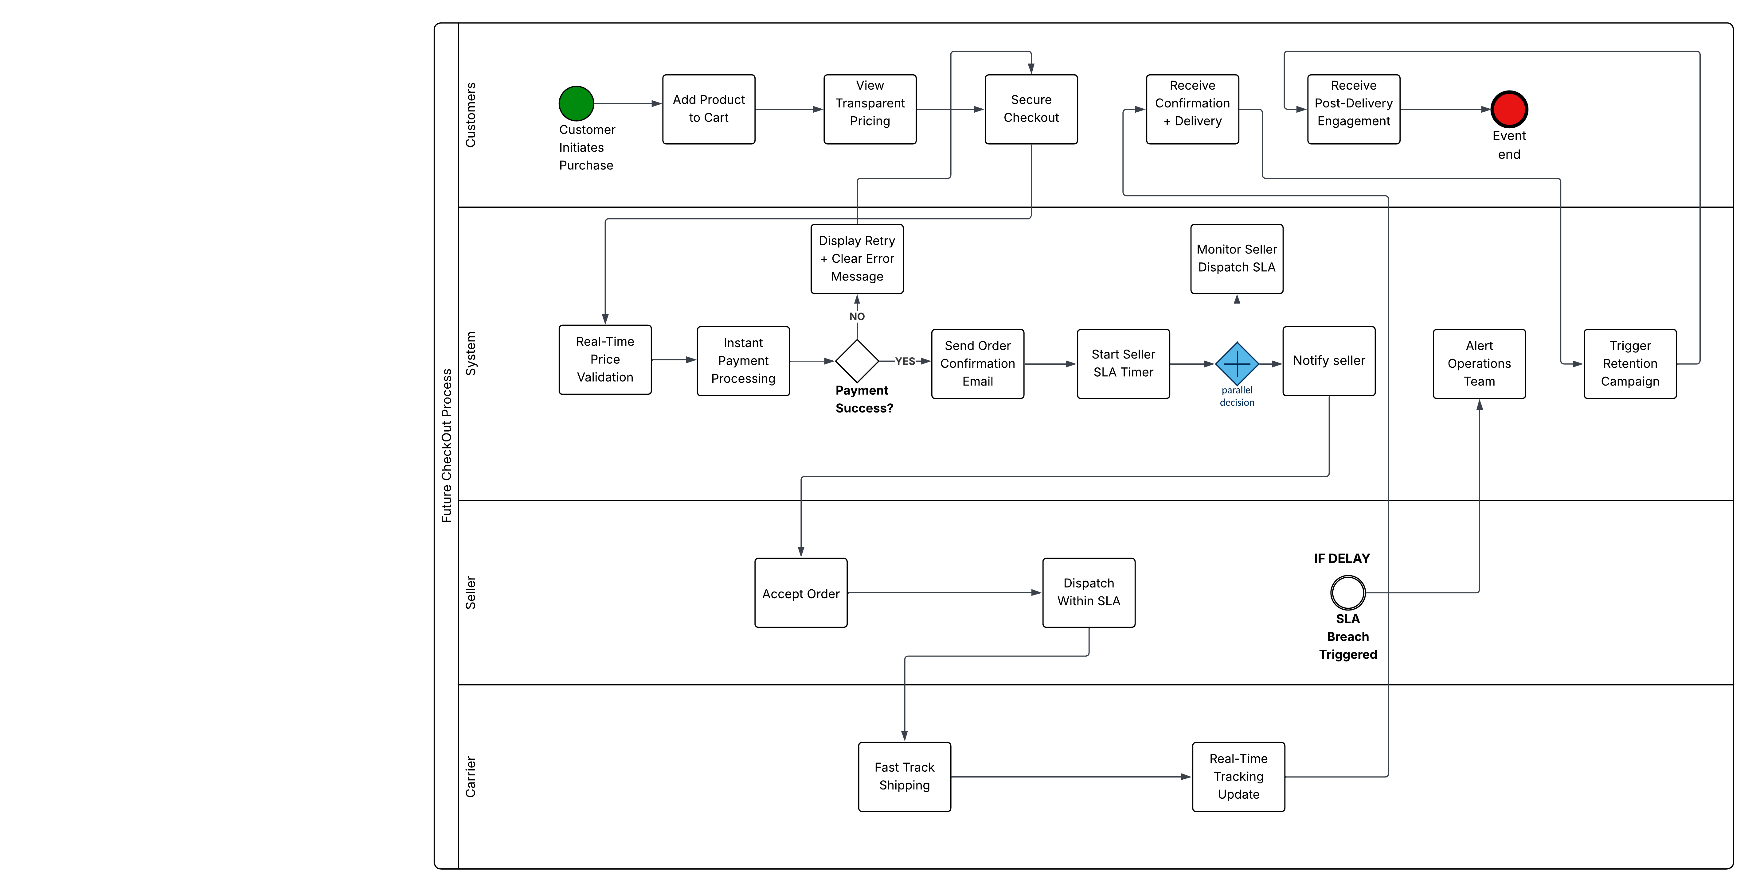
Fig 2: Future checkout process

